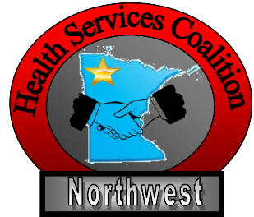
2020 Long Term Care/Assisted Living Tabletop Exercise for COVID-19

We’re in the midst of the ongoing concern for the spread of Covid-19 to our communities, which potentially will affect everyone including facilities and staff and their families.

1. What have you done to prepare your facility and staff for a potential positive patient?
2. Have you updated your plans/ policies?
3. Have you inventoried your PPE?
4. Do you have the necessary PPE?
5. How will you conserve supplies?
6. Have you trained pertinent staff on PPE, donning and doffing, and infection prevention issues? Will you do Just in Time training? Who will do the training?

One of your residents tells you that their family member has tested positive for COVID-19 and had been to visit him/her 4 days ago. So far the resident has no symptoms.

- If you don’t have signage for visitor restrictions and provide hand sanitizer at your entrances, will you do that now?
- Who will you communicate/report this possible exposure to?
- Will you quarantine the resident for 14 days?
- Will you test the resident?
- If you test and the resident is positive, what will you do with the resident if he/she is only exhibiting mild symptoms?
- Will you restrict numbers of staff that have contact with resident?
- What will be your process if the resident’s condition worsens? Who do you notify? Are you contacting a hospital before sending the resident?
- How will you handle staffing issues such as absenteeism?
- How will you secure your PPE supplies so they don’t “disappear”?
- Do you have any signed memos of understanding with any vendor, especially those who would/could provide you with PPE supplies?

Do you know who your resources are and how can they assist?

- Your “parent” company if part of a larger group?
- Other nearby facilities?
- Your Long Term Care organization?
- Local Public Health?
- South Central Healthcare Coalition?

Based on discussions above:

- What are your top 3 strengths?
- What are your gaps?
- What are your top 3 areas for improvement?

